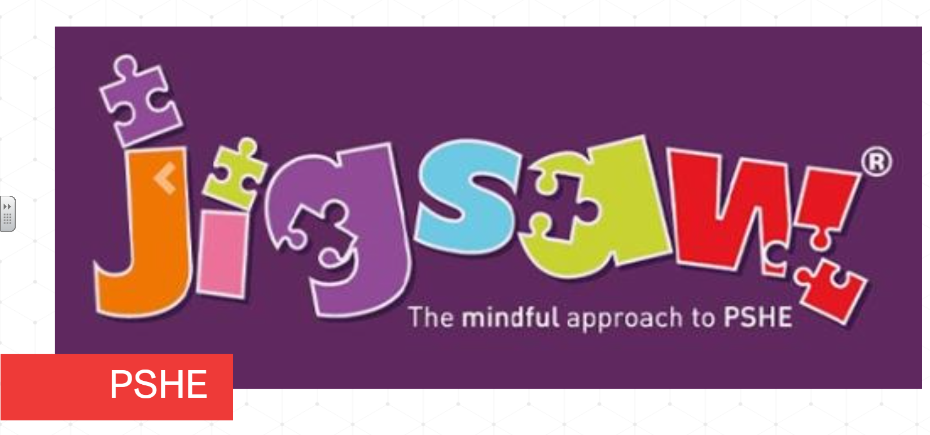
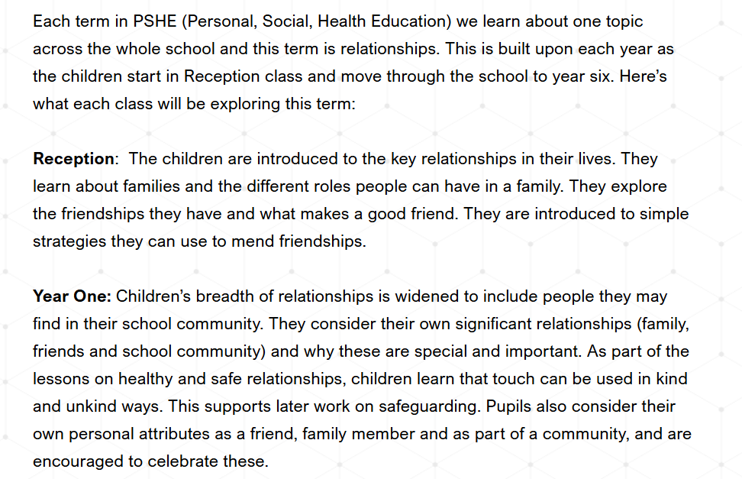
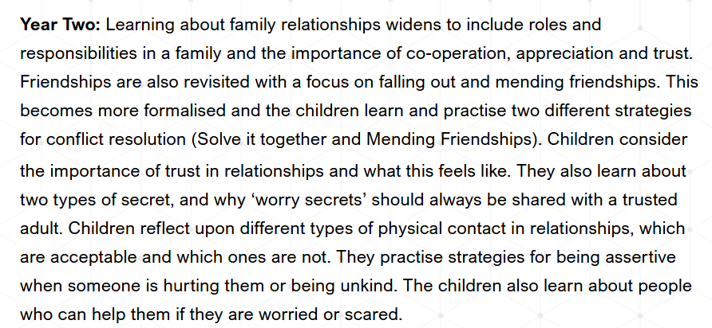

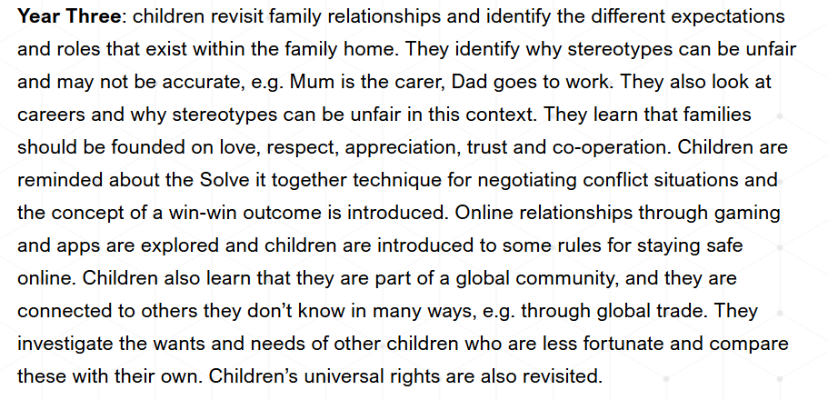

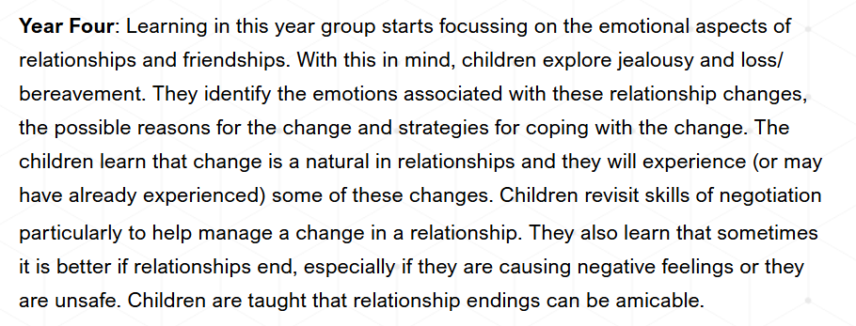

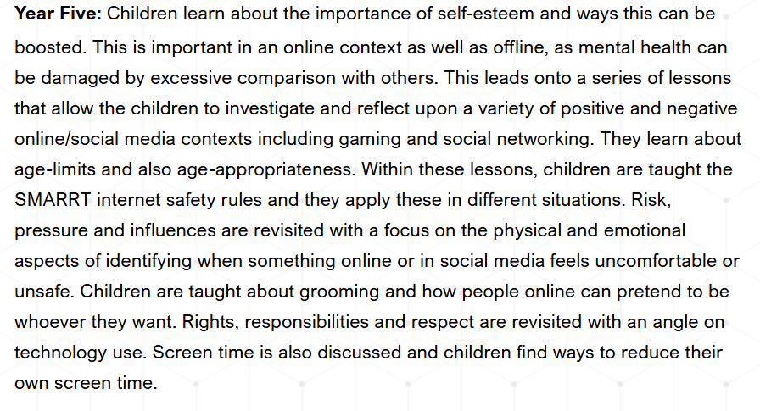
Year Six: Children learn about the importance of looking after our mental health and how to do this. They learn that there are different stages of grief and that there are different types of loss that cause people to grieve. Year six learn to recognise when people are trying to gain power or control and explore ways to stand up for themselves and their friends in situations where others are trying to gain power or control. They discuss online safety and learn to judge whether something online is safe and helpful. Children explore ways to resist pressure to do something online that might hurt ourselves, or others and how to use technology positively and safely to communicate with my friends and family.

