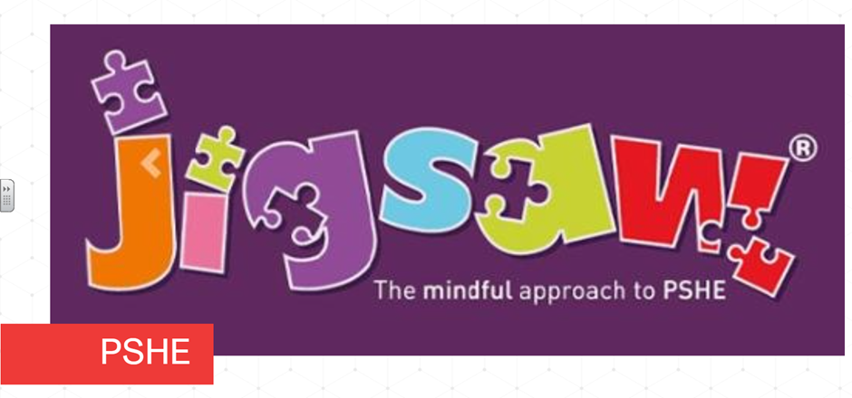Each term in PSHE (Personal, Social, Health Education) we learn about one topic across the whole school and this term is ‘Healthy Me’. This is built upon each year as the children start in Reception and move through the school to year six. Here’s what each class will be exploring this term:
Reception children learn how to exercise and physical activity. They investigate a healthy lifestyle including healthy food, sleep, keeping clean and safety.
Keys Stage One children explore keeping healthy and making healthier lifestyle choices including healthy eating and nutrition. They learn about keeping clean, being safe including medicine safety/safety with household items, and road safety. They look at linking health, happiness, motivation and relaxation.
In Year three, children look at exercise and fitness. They learn about food labelling and healthy swaps. They explore attitudes towards drugs, how to keep safe and why it’s important in online and offline scenarios. They learn how to respect themselves and others and how to make healthy and safe choices.
In Year Four, children investigate healthier friendships and group dynamics. They learn about smoking, alcohol, assertiveness and peer pressure whilst learning to celebrating their own inner strength.
Year Five children discuss smoking, including vaping, and alcohol. They explore alcohol and anti-social behaviour. They look at body image and relationships with food. They learn about healthy choices, motivation and behaviour.
Year Six children look at taking personal responsibility. They learn about how substances affect the body, exploitation, including ‘county lines’ and gang culture They discuss emotional and mental health and how to manage stress.

