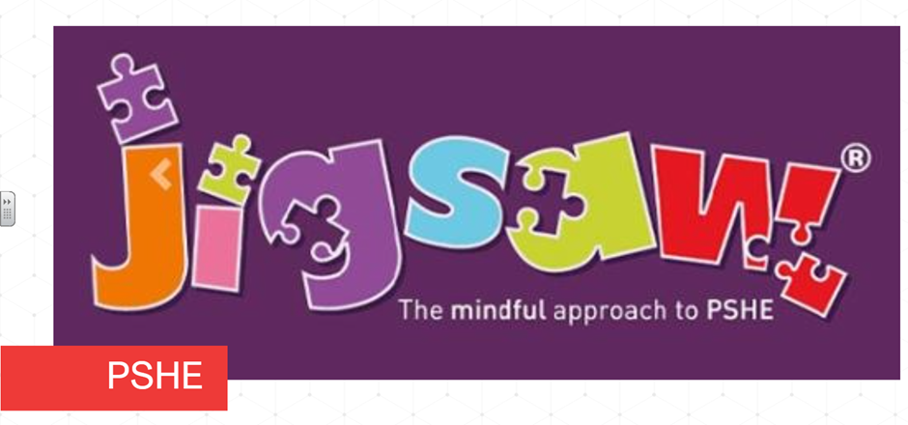Each term in PSHE (Personal, Social, Health Education) we learn about one topic across the whole school and this term is ‘Dreams and Goals’. This is built upon each year as the children start in Reception and move through the school to year six. Here’s what each class will be exploring this term:
Reception children learn about perseverance and goal setting. They explore overcoming obstacles and how to seek help. The children find out about jobs and achieving their goals.
Keys Stage One explore setting goals, identifying successes and achievements. The children find out about learning styles, how to work well and celebrating achievement with a partner. They learn how to tackle new challenges and how to identify and overcome obstacles. They explore feelings of success and achieving realistic goals. They look at perseverance, learning strengths and learning with others. They learn about group co-operation, contributing to and sharing success.
Year three children learn about difficult challenges and achieving success. They explore dreams and ambitions, new challenges, motivation and enthusiasm. They find out how to recognise and try to overcome obstacles. They evaluate learning processes, managing feelings and simple budgeting
In Year Four, children explore their hopes and dreams and overcoming disappointment. They learn how to create new, realistic dreams and achieving their goals. They learn how to work in a group, celebrate each other’s contributions whilst developing resilience and positive attitudes
Year Five children look at their future dreams, the importance of money and jobs and careers. They investigate their dream job and how to get there. They study goals in different cultures and learn ways to support others including charity. They explore motivation.
In Year Six, children find out about personal learning goals, in and out of school and success criteria. They find out about emotions involved in success and how to make a difference in the world. They explore motivation and how to recognise achievements and giving and receiving compliments.

