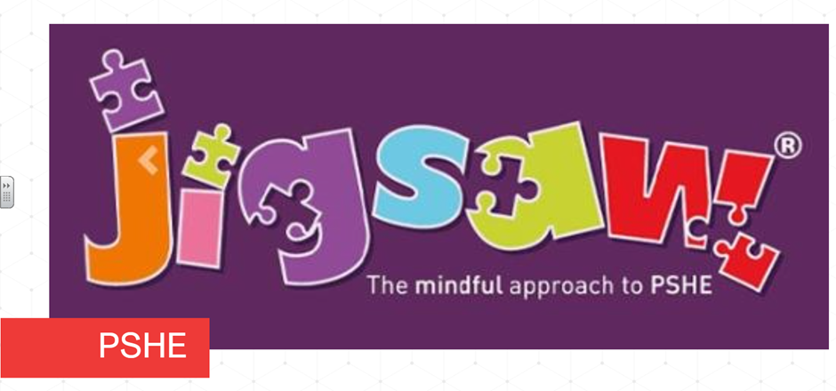Each term in PSHE (Personal, Social, Health Education) we learn about one topic across the whole school and this term is ‘Celebrating Difference’. This is built upon each year as the children start in Reception and move through the school to year six. Here’s what each class will be exploring this term:
Reception children will find out identifying talents, being special and their families. They will explore where they live, making friends and standing up for themselves.
Keys Stage One children will explore similarities and differences. They will learn about bullying, how to deal with it and how to stand up for themselves and others. They will explore how to make new friends and how to remain friends. They will discuss assumptions and stereotypes about gender and celebrate the differences in everyone
In Year Three, children learn about families and their differences. They explore family conflict and how to manage it. They discuss witnessing bullying and how to solve it. The children recognising how words can be hurtful and learn how to give and receive compliments.
Year Four children challenge assumptions and judging others by appearance. They learn how to accept themselves and others. They understand influences and bullying. They start to develop problem solving skills and identify how special and unique everyone is and explore first impressions.

In Year Five, the children explore cultural differences and how they can cause conflict. They learn about racism rumours, name-calling and different types of bullying. They look at material wealth and happiness as well as enjoying and respecting other cultures
Year Six children discuss perceptions of normality and their understanding of disability. They explore power struggles and develop their understanding of bullying, inclusion and exclusion. They learn about differences as conflict and as celebration. They learn about empathy and what this looks like.

