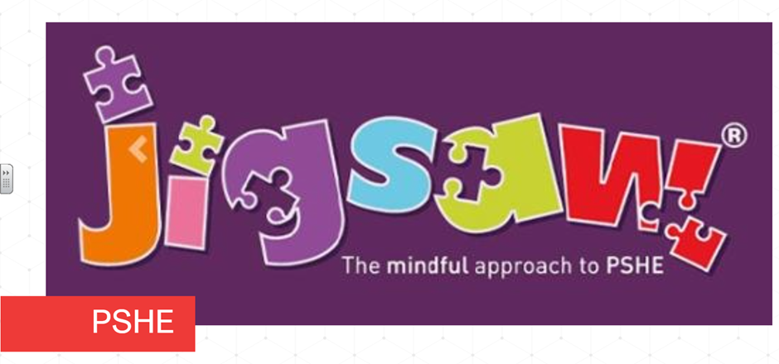Each term in PSHE (Personal, Social, Health Education) we learn about one topic across the whole school and this term is ‘Being Me In My World’. This is built upon each year as the children start in Reception and move through the school to year six. Here’s what each class will be exploring this term:
Reception children will learn about how they have similarities and differences from their friends and how that is OK. They begin working on recognising and managing their feelings, identifying different ones and the causes these can have. The children learn about working with others and why it is good to be kind and use gentle hands. They discuss children’s rights, especially linked to the right to learn and the right to play. The children learn what it means to be responsible.
Keys Stage One children will discuss rights and responsibilities, and choices and consequences. The children learn about being special and how to make everyone feel safe in their class as well as recognising their own safety. They will discuss their hopes and fears for the year ahead – they talk about feeling worried and recognising when they should ask for help and who to ask. They learn about rights and responsibilities; how to work collaboratively, how to listen to each other and how to make their classroom a safe and fair place
In Year Three, the children the children learn to recognise their self-worth and identify positive things about themselves and their achievements. They discuss new challenges and how to face them with appropriate positivity. The children learn about the need for rules and how these relate to rights and responsibilities. They explore choices and consequences, working collaboratively and seeing things from other people’s points of view. The children learn about different feelings and the ability to recognise these feelings in themselves and other
Year Four children explore being part of a team. They talk about attitudes and actions and their effects on the whole class. The children learn about their school and its community, who all the different people are and what their roles are. They discuss democracy and link this to their own School Council, what its purpose is and how it works. The children learn about group work, the different roles people can have, how to make positive contributions, how to make collective decisions and how to deal with conflict. They also learn about considering other people’s feelings
In Year Five, the children think and plan for the year ahead, goals they could set for themselves as well as the challenges they may face. They explore their rights and responsibilities as a member of their class, school, wider community and the country they live in. The children learn about their own behaviour and its impact on a group as well as choices, rewards, consequences and the feelings associated with each. They also learn about democracy, how it benefits the school and how they can contribute towards it
Year Six children discuss their year ahead, they learnt to set goals and discuss their fears and worries about the future. The children learn about the United Nations Convention on the Rights of the Child and that these are not met for all children worldwide. They discuss their choices and actions and how these can have far-reaching effects, locally and globally. The children learn about their own behaviour and how their choices can result in rewards and consequences and how they feel about this. They explore an individual’s behaviour and the impact it can have on a group. They learn talk about democracy, how it benefits the school and how they can contribute towards it

